My Favourite Memories in Scoil Bhreac Chluain.

It’s hard to believe that my time in Scoil Bhreac Chluain has come to an end already. Time flies when you’re having fun. They say that primary school are the best days of your life. Well, that’s certainly true for Scoil Bhreac Chluain.

I have a vivid memory of my first day in school. My first day of school was on September 2012. I was four years old and holding tightly to my mother’s hand. It was a special day because I was the first child in my family to go to school. I was sitting on the same table as Fionn.

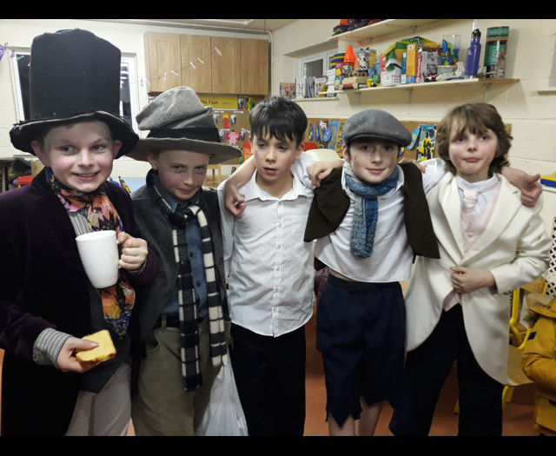Another memorable day was my Communion day. It was on Saturday the 14th of May. We were doing loads of practice to be ready for this big day. I got picked to do a prayer of the faithful. My hand was also in a cast, the week leading up to the big day.

I love Drama and I always enjoyed participating in the school plays. My favourite play was ‘Oliver’ because I got to play Bill Sikes, the villain who killed Nancy in the end.

When I was in 5th class, we went to Dublin for a badminton tournament. We had to leave really early in the morning. We played 3 group matches and won the all, so we were in the quarter finals but unfortunately, we lost to the eventual winners. That was one of my best memories.

I have thoroughly enjoyed eight wonderful years in Scoil Bhreac Chluain. I can’t believe it has come to an end. I will always look back on my time in primary school with fond memories.

The End

By Jack Lyne